

Report

© Epic Atlantic Limited
Epic Atlantic Limited
12 Kenneth Agbakuru Street, Lekki Phase I, Lagos, NG
www.epicatlantic.com | info@epicatlantic.com | +234 809 835 1008
This report contains confidential information and is intended only for the use of the individual named above. If you are not the named addressee you should not disseminate, distribute or copy this report without authorization.

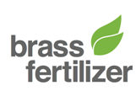


SPDC-BFPC UPSTREAM GAS SUPPLY, GATHERING,
EVACUATION & PROCESSING (UGS-GEP) PROJECT

Gas Gathering & Evacuation Pipeliness Concept Screening
Gas Gathering & Evacuation Pipelines and Gas Plant

© Epic Atlantic Limited

Epic Atlantic Limited
12 Kenneth Agbakuru Street, Lekki Phase I, Lagos, NG
www.epicatlantic.com | info@epicatlantic.com | +234 809 835 1008

This report contains confidential information and is intended only for the use of the individual named above. If you are not the named addressee you should not disseminate, distribute or copy this report without authorization.
© Epic Atlantic Limited

Epic Atlantic Limited
12 Kenneth Agbakuru Street, Lekki Phase I, Lagos, NG
www.epicatlantic.com | info@epicatlantic.com | +234 809 835 1008

This report contains confidential information and is intended only for the use of the individual named above. If you are not the named addressee you should not disseminate, distribute or copy this report without authorization.

Endorsed by:
Aloy Onyenucheya Duru, COREN (R.7580)
28th February 2017

Prepared for:
Brass Fertilizer & Petrochemical Company Limited
Doc. No. EA/SPDC-BFPC UGS-GEP/CSM-RPT-002

© Epic Atlantic Limited

Epic Atlantic Limited
12 Kenneth Agbakuru Street, Lekki Phase I, Lagos, NG
www.epicatlantic.com | info@epicatlantic.com | +234 809 835 1008

This report contains confidential information and is intended only for the use of the individual named above. If you are not the named addressee you should not disseminate, distribute or copy this report without authorization.

© Epic Atlantic Limited

Epic Atlantic Limited
12 Kenneth Agbakuru Street, Lekki Phase I, Lagos, NG
www.epicatlantic.com | info@epicatlantic.com | +234 809 835 1008

This report contains confidential information and is intended only for the use of the individual named above. If you are not the named addressee you should not disseminate, distribute or copy this report without authorization.
© Epic Atlantic Limited

Epic Atlantic Limited
12 Kenneth Agbakuru Street, Lekki Phase I, Lagos, NG
www.epicatlantic.com | info@epicatlantic.com | +234 809 835 1008

This report contains confidential information and is intended only for the use of the individual named above. If you are not the named addressee you should not disseminate, distribute or copy this report without authorization.
Statement of Confidentiality
This Conceptual Study Memorandum may contain confidential and proprietary business information of Parties involved in this project. These materials may be printed or photocopied for use in evaluating the proposed project, but are not to be shared with other parties.
Epic Atlantic Limited | 12 Kenneth Agbakuru Street | Lekki Phase I, Lagos, NG | www.epicatlantic.com | info@epicatlantic.com
SUMMARY PAGE
Client: BRASS FERTILIZER & PETROCHEMICAL COMPANY LIMITED
Project Ref: SPDC-BFPC UGS-GEP | Title: Gas Gathering & Evacuation Pipelines Concept Screening
Facilities: Gas Gathering & Evacuation Pipelines and Gas Plant | Doc No.: EA/SPDC-BFPC UGS-GEP/CSM-RPT-002

The administration of this document is in respect of the SPDC-BFPC Upstream Gas Supply, Gathering, Evacuation and Processing (UGS-GEP) Project.
The document, in consideration with relational design elements & concepts, presents the project’s concept selection study as a reference & premise to the Basic Design, as well as demonstrates readiness to progress to the Basic Design, and the subsequent FEED (Front End and Engineering Design).
It is also an input & accompaniment to the conceptual study and basic design reports & presentation to DPR as a statutory requirement in the process of securing regulators’ approval to execute the FEED / Detail Design that will lead to the project’s FID and implementation.
The report has relied and used data and reference documents provided by client, and if further document and information become available, Epic Atlantic reserves the right to update the opinion set out in this report.
For better appreciation, this document should be read in conjunction with the references listed below, which are the Concept Select Study reports that constitute basis for the Conceptual Study.
KEY WORDS: BASIS FOR DESIGN, PIPELINE, MANIFOLD, PLATFORM, GAS, plant, ROW, PTS

REferences
Document No. | Description
TO-D-AA-00001 | Basis for Design
EA/SPDC-BFPC UGS-GEP/CSM-RPT-001 | Conceptual Study Memorandum
EA/SPDC-BFPC UGS-GEP/SVY-RPT-001 | Pipeline Route Selection Study
EA/SPDC-BFPC UGS-GEP/PRC-RPT-001- 3 | Process Simulation Study – HYSYS, PIPESIM, & OLGA
EA/SPDC-BFPC UGS-GEP/MAT-RPT-001 | Pipeline Materials Selection & Corrosion Analysis Study
EA/SPDC-BFPC UGS-GEP/ELE-RPT-001 | Manifold Platforms Power Supply Options
EA/SPDC-BFPC UGS-GEP/MEC-RPT-001 | Manifold Platforms Concept & Integration with SPDC
EA/SPDC-BFPC UGS-GEP/PRC-RPT-002 | Gas Processing Technology Option

Table of Contents

1. Administration 5
1.1. Validity & Change Management 5
1.2. Background and Introduction 6
1.3. Scope of Document 6
2. Project Design Data & Basis for Design Outline 7
2.1. Project Design Data 7
2.1.1. Project Location & Operational Conditions 7
2.1.2. Production Forecast & Fluid Characteristics 8
2.1.3. Environmental Data 10
2.2. Basis for Design Outline 11
3. Project Concept and Site for the Project 33
3.1. The Gas Plant Site 34
3.2. The Gas Gathering & Evacuation Concept 35
3.3. The Gas Gathering & Evacuation Options 36
3.4. The Manifolds Concept 39
3.5. The Gas Processing 40
4. Feedstock Supply & Product Evacuation Scheme 43
4.1. The Feedstock & Products Evacuation Schematics 43

Abbreviations
The Following definitions and abbreviations have been used in this document.
Organisational
BFCL | Brass Fertilizer Company Limited
EA | Epic Atlantic Limited
SPDC | The Shell Petroleum Development Company of Nigeria Limited
Technical Terms
BBOU | Bubuowei Bou
NUNR | Non River
SEIB | Seibou
ELEP | ELEP
OPUG | Opughene
T/L | Trunkline
B/L | Bulkline
Units of Measurements
km | Kilometre
m | Metre
M | Thousand
MM | Million
MMscfd | Million Standard Cubic Feet per Day
MTPD | Metric Tonnes Per Day
Technical Terms Used for PIPESIM Simulation
BBOU | Stream coming from Bubuowei Bou manifold
ELEP | Stream coming from Elepa Satellite manifold
ELEP MF | Stream coming from Elepa Field manifold
NUNR | Stream coming from Nun River manifold
NUNR MF | Stream coming from Nun River Field manifold
SEIB | Stream coming from Siebou manifold
OPUG | Stream coming from Opughene manifold

- Administration
This Concept Screening Study is in respect of the SPDC-BFPC Upstream Gas Supply, Gathering, Evacuation and Processing (UGS-GEP) Project. It stems from the Concept Select Studies, and presents the selected design concepts as basis for the Basic Design of the project.
It is also an input and accompaniment to the Conceptual Study & Basic Design Memoranda to be presented to DPR as statutory requirements in the process of securing regulators’ approval to execute the FEED / Detail Design that will lead to the project’s FID and implementation.
  - Validity & Change Management
The report has relied and used data and reference documents provided by client. Some of the data are preliminary, based on limited information, but to a large extent, however, are adequate for this phase of work: - conceptual study and basic design.
For example, analogue PVT data was used in the absence of actual PVT, and preliminary pipeline distances were estimated based on desktop route selection study. These design data, and the consequent simulation results will invariably need to be updated during FEED, by which time actual PVT data would have been obtained, and the FP survey done to establish actual distances and elevations of the pipeline routes.
Similarly, the project timelines as set out in the execution schedule was predicated on FID date of June 2018, and that will correspondingly change with actual FID date.
Also, the security situation in the region with its wide spate of vandalism may dictate that certain design provisions be changed during the FEED. The situation will continue to be monitored, and if still perceived to be a cog in the wheel of innovation, some of the ideal designs will be replaced with what will be practically suitable for the situation.
For example, in as much as it is feasible to lay cable from the IPP to the remote manifold platforms to transmit electricity to motorise the platform valves in the Manifold Platforms Power Supply Options, or install solar systems on the platforms, there will be no need to implement such options if the facilities (cables & solar systems) will eventually be vandalised in no time. Instead, it will be rather more appealing to limit the process option to manual valve operations, without the features of valve motorisation that will require electricity.
Epic Atlantic therefore reserves the right to update accordingly, the opinion set out in this report, as further information and / or refinement become available.
  - Background and Introduction
The SPDC-BFPC Upstream Gas Supply, Gathering, Evacuation and Processing (UGS-GEP) Project is constituted by Brass Fertilizer & Petrochemical Company Limited (BFPC), in partnership with The Shell Petroleum Development Company of Nigeria (SPDC).
The project scope includes Gas Gathering Pipelines, and a Gas Process Processing Plant that will provide processed gas as feedstock to a Petrochemical Plant and a Power Plant. The Gas Processing Plant will process natural gas gathered from five SPDC fields – Bubouwe Bou, Elepa, Nun River, Seibou, and Opugbene - in OMLs 33, 32, & 36.
The Gas Plant will comprise three trains, (each with a processing capacity of 150 MMscfd) and condensate storage capacity of 50,000 Tonnes. In this respect, BFPC have concluded the Gas Supply & Processing Agreement (GSPA) with SPDC for 270 MMscfd of the natural gas feedstock. The Plants (Gas Plant, Petrochemical Plant, and Power Plant) will all be located in the same complex at Akabel, Brass Island, Bayelsa state of Nigeria, near the shores of Atlantic Ocean.
The Petrochemical Plant will comprise a Methanol Plant of 1.75 MTPA capacity, and a Urea Plant of 2.6 MTPA total capacity, built in two phases of 1.3 MTPA each. It will also have storage capacity for 150,000 Metric Tonnes of Methanol and 100,000 Metric Tonnes of Urea. The facilities complex will also comprise a captive export jetty of 4 berths for up to 35,000 DWT vessels.
The current on-stream date for the project is December 2020, and to achieve that, FID is planned for June, 2018. In pursuit of these business objectives, BFPC have virtually concluded Project Management & EPC contracts with EIL, Saipem, and TCC, who are internationally renowned contractors in the implementation of the subject projects type.
The Gas Processing Plant, and the associated Gas Gathering System / Pipelines which will transport wellhead gas from the SPDC fields to the Gas Processing Plant, constitute the key upstream enabler facilities for the realisation of the objective supply of processed gas supply as feedstock to the Petrochemical Plant for the product manufacturing of methanol & urea, and to the Power Plant for power generation.
  - Scope of Document

The scope of the document covers the Conceptual Study and its evolution of results that will shape the basic design of the project along the following subjects:
- Project Design Data & Basis for Design Outline
- Project Concept and Site for the Project
- Concept Select Drawings
- Project Design Data & Basis for Design Outline
Ref: TO-D-AA-00001-R01_Basis for Design
The Project Design Data & Basis for Design Outline as summarised here form the technical basis for the conceptual study, and subsequent development of the Basic Design and FEED for the project’s EPC, albeit updates that will arise following additional data acquisition or refinement.
  - Project Design Data
The key design data required & used are: Project Location Plan & Operational Conditions, the Natural Gas Conditions, Compositions, & Flow Rates, Production Forecast & Fluid Characteristics, and Environmental Conditions.
    - Project Location & Operational Conditions
The project location plan & operational conditions are summarized in the table below.
Table 2.1: Project Location Plan & Operational Conditions
1 | Location | OML 33 / 32 / 36 - with the fields widely spread & on both sides of Nun River
2 | Target Fields | BBOU, ELEP, NUNR, SEIB, & OPUG  BBOU & ELEP in OML 33 and NUNR in OML 32, - East of Nun River  SEIB in OML 32 and OPUG in OML 36, - West of Nun River
3 | Desired Offtake Rate / GSPA Contractual Rate | 300 MMscfd / 270 MMscfd, starting at 110 MMscfd in Year 1, ramping up to 300 MMscfd in Year 4
4 | Gas Offtake Points | SPDC Field Manifold Headers at the target fields, in phases starting with BBOU, then ELEP, NUNR, SEIB, & OPUG
5 | Feed Stream Inlet Pressure to BFPC P/L System | 80 – 100 barg
5 | Feed Stream Outlet Pressure from BFPC P/L System to Gas Plant | 60 – 65 barg
5 | Gas Plant Processed Gas Outlet Pressure | 50 – 55 barg
6 | Condensate | 5 – 45 Mbpd
7 | Water Production | Starting at 1.5 Mbpd in 2026, increasing to about 20 Mbpd in 2032

    - Production Forecast & Fluid Characteristics
The production forecast and fluid characteristics are summarized below.
Figure 2.1: Fields’ Gas Production Forecast – Facilities Design Data

Gas Composition
The gas compositions of the five fields are as summarised in the tables below:
Table 2.1: Fields’ Reservoir Compositions & Conditions – as received.

Table 2.1: Fields’ Reservoir Water-Saturated Compositions & Conditions – as constructed using HYSYS

    - Environmental Data
The environment is mangrove swamp and brackish water of resistivity assumed 1000 - 5000 ohm – cm, based on regional data.
- Environmental (Outdoor) Conditions
Design Barometric Pressure | 1.013 bara
Design Ambient Temperature - Maximum | 42ºC
Mean Maximum Ambient Temperature | 31ºC
Design Ambient Temperature - Minimum | 18ºC
Mean Minimum Ambient Temperature | 23ºC
Relative Humidity | 100%
Thermal Insulation Design Criteria | 23ºC at 100% Humidity
Black Bulb Temperature | Up to 80ºC
Ground Temperature | 25 – 28 ºC
Site Altitude | Sea Level
Lightning | Frequent in Rain
Average Annual Rainfall | 3,800 in
Mean Maximum Hourly Rainfall | 100 in
Design Wind Speed | 36 m/s (130 km/hr)
Corrosion Environment | Brackish Swamp/Waters (50 -100 ohm-cm)

- Indoor Conditions
The control equipment and HV/LV-boards will be installed in air-conditioned non-hazardous control rooms, with environmental conditions as follows:
Ambient Air Temperature | 20 – 22 ºC
Relative Humidity | 50 – 75 %

Electronic Equipment (e.g. signal converters / barriers) shall also be capable of operating at a temperature of at least 75°C.
Equipment shall also be capable of operating at a room temperature of 55°C to cover shutdown of air conditioning.
The operator stations will be installed in an air-conditioned, non-hazardous control room with conditions as follows:
Ambient Air Temperature | 21 + 3 ºC
Relative Humidity | 50 – 75 %

Environment / Resistivities Vs Corrosion Current per m²
The assumption made for the current density for bare steel metal areas for this desk top calculations is 22 mA / m² at the assumed resistivity of 1000 – 5000 ohm-cm of the swampy, brackish water environment closed to the brass sea
Coat Efficiency
Coat efficiency, Mean Coating Breakdown and coating Breakdown at end of life time

  - Basis for Design Outline

The key BFD elements are summarised in the fishbone diagram below, and the matrix that follows.
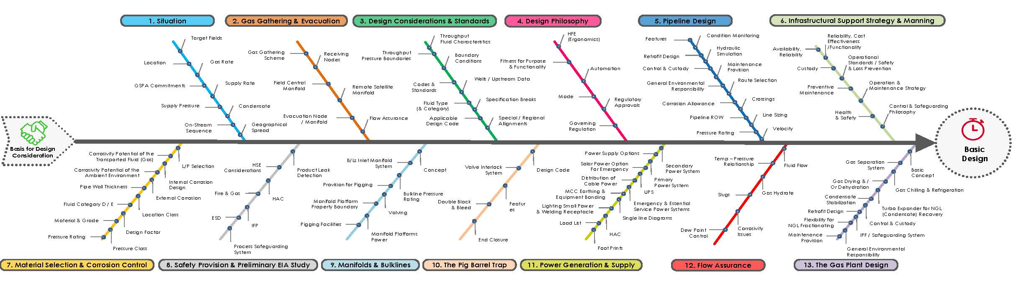
Figure 2.1: Fields’ Gas Production Forecast – Facilities Design Data

Table 2.2: BFD Matrix
 | Situations & Systems |  |  | Design Basis |  | Remark / Reference
1 | Location
 | 1.1 | Gas Source |  |  | OML 33 / 32 / 36 - with Locations Widely Spread & on Both Sides of Nun River
 |  | 1.1.1 | Target Fields |  | BBOU, ELEP, NUNR, SEIB, & OPUG
 |  |  |  |  | BBOU & ELEP in OML 33 and NUNR in OML 32, - East of Nun River
 |  |  |  |  | SEIB in OML 32 and OPUG in OML 36, - West of Nun River
 | 1.2 | Gas Gathering scheme |  |  | Nodal Raw Gas Gathering thru Pipeline Network to ELEP, and from there to Akabel
 |  | 1.2.1 | Receiving Nodes |  | Three Nodes - ELEP, BBOU, & NURN Node - geographically convenient
 |  |  |  |  | NUNR & SEIB Production to NUNR Node S-M/F - geographical convenience
 |  |  |  |  | BBOU & OPUG Wells Production to BBOU Node S-M/F - geographical convenience
 |  |  |  |  | ELEP Wells Production, BBOU Node Inventory, & NUNR Node Inventory to ELEP Node E-M/F - geographyical convenience
 |  | 1.2.2 | Evacuation Node |  | ELEP Manifold
 |  |  |  |  | Inventory from ELEP Node E-M/F to AKAB PLEM, and from there to the Gas Plant

 |  | Situations & Systems |  |  |  | Design Basis |  | Remark / Reference
1 |  | Location (Contd.)
 |  | 1.3 |  | Gas Gathering System |  |  | A mix of Wellhead Flowlines, Field Manifolds, and Bulk Transport Lines, - optimally configured in terms of cost, layout, and choice of evacuation manifold (Bubouwe Bou or Elepa)
 |  |  |  |  |  |  | Wellhead Flowlines Gather Each Field Production into the Central Field Manifold (F-MF) within the Field, followed by:
 |  |  |  |  |  |  | Transportation of the F-MF inventory through Bulkline to Satellite Manifold (S-MF) / Evacuation Manifold (E-MF).
 |  |  |  |  |  |  | Transportation of the S-MF inventory through Bulklines to the E-MF
 |  |  |  |  |  |  | Transportation of the E-MF inventory through a Trunkline to the Gas Processing Plant.
 |  | 1.4 |  | The Gas Processing Plant |  |  | The Gas Plant will be located at Akabel, Brass Island, Bayelsa State of Nigeria, near the shores of Atlantic Ocean
 |  |  |  |  |  |  | The Plant Site is in the same complex with the Petrochemical Plant and the Power Plant that it will be supplying the processed gas
2 | Business Case
 | 2.1 |  | Justification |  |  |  | To supply processed gas needed as feedstock to Petrochemical Plant and a Power Plant, - in the value chain for methanol & urea production by the petrochemical plant, and power generation by the power plant
 |  |  |  |  |  |  | GSPA with SPDC in place for the Supply of the Natural Gas to be Processed

 | Situations & Systems |  |  |  | Design Basis | Remark / Reference
2 | Business Case (Contd.)
 | 2.2 |  | GSPA |  | Wellhead (Raw) Gas at Each of the Fields' Manifolds for offtake by BFPC through own Bulklines
 |  |  | 2.2.1 | Gas | 270 MMscfd
 |  |  | 2.2.2 | Supply Pressure | 80 - 100 barg
 |  |  | 2.2.3 | Condensate | 5 - 45 Mppd
 | 2.3 |  | On-Stream Sequence |  | Phased Sequential (Production) Injection: BB ELEP + NUNR + SEIB + OPUG in that order, - with stop points driven / moderated by the GSPA
3 | Gas Offtake / Flow Conditions
 | 3.1 | Flow Rates / Fluid Characteristics |  |  |  | 5- 45Mbopd of Condensate  Also water production will occur later, starting at 1.5 Mbpd in 2026 increasing to about 20 Mbpd in 2032  Fluid therefore to be considered two phase since no treatment will be done before injection into the Line, - prompting design of the Pipeline for two-phase Handling  Two Phase Gas Transportation all the way to the Gas Processing Plant at Akabel  Consequence is that Frequent Pigging will be needed to keep the Lines operating
 |  | 3.1.1 |  | Gas Production | 300 MMscfd Peak (Start 110 in Year 1, Ramping up to 300 in Year 4)
 |  |  |  | Condensate Production | Up to 45,000 bpd
 |  |  |  | Water Production | Up to 350 bpd from the water content of the Natural Gas
 |  |  |  |  | Up to 20 Mbwpd reservoir production, starting later in the fields' life
 |  |  |  | CGR | 4 - 36 for BBOU, 62 - 158 for the rest
 |  | 3.1.2 |  | Gas SG | 0.6 - 0.74 (Air = 1)
 |  |  |  | Condensate SG | 0.74
 |  |  |  | Water SG | 1.00 - 1.02
 |  | 3.1.3 |  | Corrosivity Potential | Envisaged, on account of CO₂ in the gas stream
 |  | 3.1.4 |  | Souring Potential | Not Envisaged, - since no H₂S in the gas stream
 |  | 3.1.5 |  | Foaming Potential | Not Envisaged
 |  | 3.1.6 |  | Scaling Tendencies | Not Envisaged

 | Situations & Systems |  |  |  |  | Design Basis | Remark / Reference
3 | Gas Offtake / Flow Conditions (Contd.)
 | 3.2 | Pressure Regime |  |  |  |  | Provision to accommodate higher pressure (up to 110 barg) at the distant field manifolds of Seibou & Opugbene.
 |  | 3.2.1 |  | Feed Stream Inlet Pressure |  | 80 - 100 barg
 |  | 3.2.2 |  | Feed Stream Outlet Pressure |  | 60 - 65 barg
 | 3.3 | Product Metering |  |  |  | The NAG facility shall be provided with metering devices for gas and condensate flows. These meters shall be allocation type meters. All the instruments provided shall meet the Hazardous area requirements for field instruments
 |  | 3.3.1 |  | Raw Gas Metering |  | Conditioning Orifice Metering at the Custody Transfer Points at the Field Manifolds
 |  | 3.3.2 |  | Feed Stream Outlet Pressure |  | 60 - 65 barg
4 | Design Philosophy
 | 4.1 |  | Fitness for Purpose & Functionality |  |  | Driven by an understanding of what constitutes a good (an excellent) design that will deliver technical & operational excellence; - requiring a good knowledge of how humans interact within the work system
 |  |  | 4.1.1 |  | Human Factors Engineering (Ergonomics) | Inclusion of User Requirement through:  - Consideration to human capabilities, limitations and needs in the interaction between humans, technology and the working environment.  - Equipment, Valves, Controls & Accessories Layout, degree of automation, and extent of protective systems. | Operability and Maintainability of the System to be given priority, considering the perculiarities of geographical locations of the Facilities
 | 4.2 |  | Mode |  |  | Not normally manned facility, with Automatic Shutdown Capability | Automatic Shutdown to be Fail Safe  Consideration to the use of Self Contained Fail Safe Shutdown System that Requires Human Intervention for Reopening
 |  |  | 4.2.1 |  | Automation | Remote Shutdown Capability from a PLC based Control Room.
 |  |  |  |  |  | Remote start-up capability with local permissives from the Field M/F & PLEM, Either as a provision, or intended start-up process for the P/L | This will require the Installation of Patch Panels & Fieldbuses. For such a small installation, it will be more economical to keep automation as simple as possible
 |  |  |  |  |  | Local Control Room, with HMI
 |  |  |  |  |  | PLC with SCADA capability
 | Situations & Systems |  |  |  |  | Design Basis | Remark / Reference
4 | Design Philosophy (Contd.)
 | 4.3 |  | Governing Regulations |  |  | Oil Pipelines Act, Chapter 338, Laws of the Federation of Nigeria 1990  DPR Guidelines for Installation of Gas Plant
 |  |  | 4.3.1 |  | Regulatory Approvals | PTS (Permit To Survey)  OPL (Oil Pipeline Licence)  EIA (Environmental Impact Assessment Study)  Staged Approvals contained in DPR Guidelines for Gas Plant Facility and Oil & Gas Pipeline Systems
 |  |  | 4.3.2 |  | Refence DPR Guidelines | Guidelines for the Establishment of Natural Gas Plant Facility in Nigeria  DRP P-1P: Guidelines & Procedures for the Design, Construction, Operation and Maintenance of Oil & Gas Pipeline Systems in Nigeria - 2007
 | 4.4 |  | Codes & Standards |  |  |  | ISO 13623:2009 §  BS EN 14161:200 - § 5.2  Shell DEP 31.40.00.10-Gen - $ 2.1  FLIUD IS TO BE CONSIDERED TWO PHASE SINCE NO TREATMENT WILL BE DONE BEFORE INJECTING INTO THE LINE  Applicable Design Code for Category D and E fluids, ref:  Shell DEP 31.40.00.10-Gen  ISO 13623:2009 / BS EN 14161:200
 |  |  | 4.4.1 |  | Fluid Type (& Category) | Gas (Category D / E)
Category D:
Non-toxic, Single-phase Natural Gas
Category E:
Flammable, and/or toxic fluids which are gases at prevailing ambient temperature and atmospheric pressure conditions and are conveyed as gases and/or liquids. Typical examples are Hydrogen, Natural Gas (not otherwise covered in Category D), Ethane, Ethylene, LPG (such as Propane & Butane), Natural Gas Liquids, Ammonia and Chlorine.
 |  |  | 4.4.2 |  | Applicable Design Code | ANSI / ASME 31.8 - Pipeline & Field Manifolds  ANSI / ASME 31.3 - PLEM
 |  |  | 4.4.3 |  | Specification Breaks | ANSI / ASME 31.3 - at the Gas Plant Fence, as PLEM is within the Gas Plant Fence; as well as athe Manifold Platforms

 | Situations & Systems |  |  | Design Basis | Remark / Reference
5 | Pipeline Design
 | 5.1 | Design Provisions |  | Pipelines, Node M/Fs and PLEM
 |  | 5.1.1 | Features | Coated Linepipe / Field Joints Coating - for external corrosion protection | - 3 Layers PE (Poly Ethylene) Main Line Coating  - GTS 65 Field Joints Coating
 |  |  |  | Concrete Coating of River Crossing Sections to Combat Buoyancy
 |  |  |  | Pig Launcher / Receiver with Capability for Intelligent Pigging
 |  |  |  | Provision for Chemical Injection Facilities on the Manifold Platforms - for Corrosion Inhibition Administration to Mitigate Internal Corrosion
 |  |  |  | Pipeline End Manifolds on Manifold Platforms at Gas Gathering Nodes
 |  |  |  | Provision for Power Supply & Related Power Distribution Ancillaries at the Manifold Platforms that will enable powered equipment operations / automation, and data transmission for monitoring of the pipeline. | Concept selected among other options - Solar Power & Indivudual Power Generator options at Each Manifold
 |  |  |  | Cathodic Protection System to Combat External Corrosion | Inmpressed Current
 |  |  |  | Sectionalisation Valves at River Crossings / at 30 km Intervals | ASME Requirement
 |  | 5.1.2 | Retrofit Design | Retrofit Design on Node Manifold Platforms in the light of sequential injection
 |  | 5.1.3 | Power Supply Options | Power Plant at Akabel Base to generate electricity for the base operations, and export to the Pipelines Manifold Platforms
 |  | 5.1.4 | Control & Custody | The automated block valves will be remotely controlled from BFPC Control Centre. Custody tranfer metering will be installed at each of the SPDC M/Fs
 |  | 5.1.5 | Health & Safety | Design will provide for healthy and safe work environments for operation & maintenance.
 |  | 5.1.6 | General Environmental Responsibility | Protective devices and containment will be installed at the facilities; mainline valves will be remotely operable where practical

 | Situations & Systems |  |  | Design Basis | Remark / Reference
5 | Pipeline Design (Contd.)
 | 5.2 | Line Sizing |  | To Meet Throughput, Pressure & Velocity Boundary Conditions
 |  | 5.2.1 | Inlet Pressure | 80 - 100 barg (1,160 - 1,450 psi) | Delivery Pressure Available at CTP
 |  | 5.2.2 | Outlet Pressure | 60 - 65 barg (870 - 942 psi) | High enough to satisfy the requirements of the Gas Plant
 |  | 5.2.3 | Pressure Drop | Applicable Equation: - Panhandle Equation  (Long Distance, Large Diameter Pipelines)
 |  |  |  | Steady State Hydraulic Simulation done on HYSYS, & PIPESIM
 |  |  |  | Dynamic Hydraulic Simulation done on OLGA
 |  |  |  | Line Sizing Cosscheck with Panhandle Equation
 |  | 5.2.4 | Velocity Considerations | Minimum Velocity to prevent surging, and to keep line swept clear of entrained solids & liquids  Maximum Velocity that will not cause Erosion, Excess Noise, or Water Hammer
 |  | 5.2.5 | Velocity | 5 - 20 m/s: subject to Errosional Velocity Limit | API RP 14E
 |  | 5.2.6 | Minimum Velocity | High enough to prevent surging, and to keep line swept clear of entrained solids & liquids | Too low a velocity leads to settlement of water, which may lead to bottom of pipe internal corrosion
 |  | 5.2.7 | Maximum Velocity | Low enough to avoid erosion, excess noise, or water hammer | Too high a velocity can increase the overall corrosion rate and also destroy any protective scale or inhibitor films.

 | Situations & Systems |  |  | Design Basis | Remark / Reference
5 | Pipeline Design
 | 5.3 | Pipe Wall Thickness |  | To Meet Design Code, Pipe Material & Grade, Fluid's Pressure, Chemical Composition, Velocity, & Velocity Boundary Conditions
 |  | 5.3.1 | Fluid Category D / E | Category D:  Non-toxic Single-phase Natural Gas  Category E:  Flammable fluids which are gases at prevailing ambient temperature and atmospheric pressure conditions and are conveyed as gases and/or liquids. Typical examples are Natural Gas (not otherwise covered in Category D), Ethane, Ethylene, LPG (such as Propane & Butane), Natural Gas Liquids. | ISO 13623:2009  Shell DEP 31.40.00.10-Gen
 |  | 5.3.2 | Location Class | Class 1 / Class 2 Locations | 5 - 30 residential buildings per km
 |  | 5.3.3 | Design Factor | Geographical 0.72, Crossings without Casings 0.6
 |  | 5.3.4 | Material & Grade | API X65
 | 5.4 | Pressure Rating |  | To Meet ANSI Standard B16.5 / API Spec 6A
 |  | 5.4.1 | Pressure Class | ANSI 900 (Class 900)
 | 5.5 | Maintenance Provisions
 |  | 5.5.1 | Corrosion Management | Provision will be made for corrosion inhibitor injection to mitigate corrosion of the pipeline | The Gas is potentially corrosive on account of its CO₂ content above threshhold for corrosion; and water, NGL, & particulates that are inherentltly present
 |  |  |  | Provision will also be made for cleaning and in-line inspection tools, shop, and in-situ maintenance
 |  | 5.5.2 | Condition Monitoring | UT Scanning
 |  |  |  | Intelligent Pigging
 |  |  |  | Leak Detection will be installed for pipelines and facilities

 | Situations & Systems |  |  | Design Basis | Remark / Reference
6 | Pipeline Routing
 | 6.1 | Route Selection |  | Desk-top Exercise, pending PTS / detailed survey that will enable Final Route Selection
 |  |  |  | Route Optimised in the Light of Environmental Impact / Impact to Settlements
 |  |  |  | Consideration given to Economic Distances / Workable Routes
 |  |  |  | Current Concept for BBOU / ELEP is: 16" x 9km from BBOU - ELEP, and 24" x 28.5 km from ELEP - AKAB, running through Southern Ijaw, Nembe, & Brass LGAs
 |  |  |  | Alternative of 42 km predominatly offshore route, aimed at minimising communities traverse was considered, but dropped, as it did not achieve that objective, in addition to the intelligence report that it will not be acceptable to NIWA. | Further the alternative offshore route will mean higher installation, and risk of hydrate formation for the lower ambient temperature
 | 6.2 | Pipeline ROW |  | Desk-top Exercise, pending PTS / detailed survey that will enable Final Route Selection
 |  | 6.2.1 | Width | 30 m - (15 m for P/L, including FOC, and 15m provision for Construction equipment & activities
 |  | 6.2.2 | Route Excavation | Propose to excavate route as 1 - 1.5 m deep trench that will be backfilled
 |  |  |  | The alternaive of open ditch (3m width X 4m depth), was considered in the light than it will be permanently flooded and will therefore pose as deterrent against vandalisation, - but was dropped as that objective is uncertain to be achieved. | Further the alternative open ditch canal option will mean higher installation cost that will include additional equipment and weight (concrete) coating of linepipes
 |  | 6.2.2 | Crossings | Crossings of Existing pipelines, Cables, Power Lines, Roads, and Waterways to be maintained at an angle between 60 & 90 degrees
7 | Flow Assurance
 | 7.1 | Essence |  | Process conditions should be such that upstream pressure is sufficient to deliver fluid to destination, as well as avoid precipitation & deposition of solids

 |  | Situations & Systems |  |  |  |  | Design Basis | Remark / Reference
 | 7 | Flow Assurance (Contd.)
 |  | 7.2 |  | Fluid Flow |  |  | Hydraulic Flow, on own Pressure | Hyraulic Analysis to be performed to establish range of operational parameters of the Pipeline
 |  |  |  | 7.2.1 | Temp - Pressure Relationship |  | T & P to be maintained below equilibrium line for hydrate formation, otherwise chemical (antifreeze) injection
 |  |  |  | 7.2.2 | Gas Hydrate |  | Need for the Fluid Traverse to be maintained outside Hydrate Formation Envelop
 |  |  |  | 7.2.3 | Dew Point Control |  | Dew Pointing & Hydrate Handling in respect of the Gas Processing will be addresses at the Gas Plant FEED
 | 8 | Pipeline Materials Selection & Corrosion Analysis
 |  | 8.1 | Drivers |  |  |  | Internal & External Corrosion Predictions and Design Life, Fitness & Compatibility
 |  | 8.2 | Essence |  |  |  | Specification of Materials that can withstand the physical conditions and application, as well as work together
 |  | 8.3 | Situations |  |  |  | High Pressure Transportation of Category D/E Fluid (flammable fluid), in the pressure region of 100 barg, and temperature region of 60 ºC
 |  | 8.4 | Components of Concern |  |  |  | Obnoxious Components of Concern are: CO2, H2S, Mercury, and Naturally Occurring Radioactive Materials (NORM)
 |  |  | 8.4.1 |  | CO₂ |  | CO₂ content is up to 2%, which for the empirically established 0.1 bar partial pressure treshhold for significant CO₂ corrosion, implies corrosion of unprotected mild CS at pressures above 5 barg | DeWaard-Milliams CO₂ Corrosion Nomogram
 |  |  | 8.4.2 |  | H₂S |  | Nil in the gas streams, - hence no sour gas corrosion to contend with
 |  |  | 8.4.3 |  | Mercury |  | No Mercury Present , - to cause mercury amalgamation and embrittlenes of alumunium and other metals
 |  |  | 8.4.4 |  | NORM |  | No NORM (Naturrally Occuring Radioactive Materials), - Radon, Radium, - which can accumulate within P/L & Process Eqpt to render them radioactive over time
 |  | Situations & Systems |  |  |  |  | Design Basis | Remark / Reference
8 |  | Pipeline Materials Selection & Corrosion Analysis (Contd.)
 |  | 8.5 | Issues & Consideration |  |  |  | The CO₂ content of up to 2%, renders the gas corrosive at pressures higher than 5 barg (corresponding to to the empirically established 0.1 bar partial pressure treshold for significant CO₂ corrosion), - prompting the need for CRA materials or matching corrosion management design | Internal Corrosion Issue
 |  |  | 8.5.1 |  | Corrosivity Potential of the Transported Fluid (Gas) |  | The Gas is potentially corrosive on account of its CO₂ content; and water, NGL, & particulates that are inherentltly present | Assessments Based on:  - HydroCor Softeware and External Resistivity Analysis  - DeWaard-Milliams CO₂ Corrosion Nomogram
 |  |  |  |  | Corrosivity Potential of the Ambient Environment |  | Humidity, Acidity, and Oxygen in Air, and known potentially corrosive nature of the soil in the area jointly contribute to render the ambient environment corrosive | External Corrosion Issue
 |  |  | 8.5.2 |  | Internal Corrosion Design |  | Materials Selection - NACE Codes, Consideration for MS (WT), MS (WT)+CA, MS+Inhibitor, MS with CRA
 |  |  | 8.5.3 |  | External Corrosion |  | Coating Selection and Painting - NACE Code | Main Line Coating with 3 Layers PE (polyethylene)  Field Joint Coating with GTS 65
 |  |  |  |  |  |  | CP Design NACE Code IP
 |  |  |  |  |  |  | T/R, Junct Boxes, Cabling, (IAC Code), Groundbed design, Electrical Seperation
 |  | 8.6 | Line Pipe Selection |  |  |  | API 5L X65 Mild Carbon Steel | Duplex Stainless Steel for the Flowlines & Field Manifold Headers on the Manifold Platforms
 |  |  |  |  |  |  | High Yield Strength (a favourable trade-off with required wall thickness) that can accommodate high corrosion allowance that will be needed
 |  | 8.7 | Corrosion Allowance |  |  |  | Up to 10 mm, and will be supported with Corrosion Inhibition

 | Situations & Systems |  |  | Design Basis | Remark / Reference
9 | Manifold Platforms
 | 9.1 | Concept |  | Integrated Field Manifold Platform for both SPDC Field Manifold Header & BFPC Bulklines
 | 9.2 | The Manifold Platform |  | Comprises Field Manifold Header, Incoming & Outgoing Bulklines and Scraper Barrels, Chemical Injection System, Electrical Transformer, & Electric Room
 |  | 9.2.1 | B/L Pressure Rating | ANSI 900 | ANSI 1500 for the Well Flowlines
 |  | 9.2.2 | Provision for Pigging | The Pipeline Manifold equipped with Pigging Facilities (Pig Launcher / Receiver) for pigging / pipe cleaning that will be done during precommissioning, commissioning & decommissioning of pipeline, and routine cleaning and condition monitoring of the pipeline during its operations
 |  | 9.2.3 | Valving | Valving arranged and labelled so that they can be acessed safely and efficiently; the required valve can be visually identified and distinguished without error; the information required for decision making is provided; and the physical and mental workload required remains within reasonable limits. Task demands should not exceed operator capbilities
 |  |  |  | IVA (Identification Valve Analysis) to ensure that all valve configurations are well designed from an operational task performance perspective, and to avoid design misfits in category 1 valves (critical). A key objective is to ensure that valves are properly categorised and prioritised at an early stage in design.
 |  |  |  | Valve Interlock System
 |  |  |  | Unrestricted Access for Valves used for emergency operations (i.e. Category 1 valves)
 |  | 9.2.4 | Manifold Platform Property Boundary | Will be Fenced / Caged to Ward off Intrusion
 |  | 9.2.5 | The Pig Barrel Trap | Horizontal Pig Trap, wiith capability for intelligent pigging
 |  | 9.2.6 | Pressure Rating | ANSI 900
 |  | 9.2.7 | Design Code | ASME 31.8 for the Infield M/F Pig Traps, and  ASME Section VIII for Pig Trap EnclosureE  ASME 31.3 for the PLEM Piping
 | Situations & Systems |  |  | Design Basis | Remark / Reference
9 | Manifold Platforms (Contd.)
 | 9.2 | The Manifold Platform (Contd.)
 |  | 9.2.8 | Corrosion Allowance | Yes, - as raw gas contains CO₂ at threshhold concentration for Corrosion
 |  | 9.2.9 | Double Block & Bleed | Two separate valves in series with a bleed (vent) point in between to allow diversion to safe location of any fluid leaking through either valve
 |  | 9.2.10 | End Closure | End Closure pointing away from personnel areas and critical items of equipment, in the event of pig being ejected from the pig trap | Consideration Given TO ADDITIONAL SAFETY MEASURES LIKE USING INTERLOCKING KEY SYSTEM TO OPEREATE THE PIG TRAP SYSTEM.
 |  | 9.2.11 | Valving | Valving arranged and labelled so that they can be acessed safely and efficiently; the required valve can be visually identified and distinguished without error; the information required for decision making is provided; and the physical and mental workload required remains within reasonable limits. Task demands should not exceed operator capbilities | PIPELINE VALVES TO BE DESIGNED AS PER ASME B16.34 AND ASME B16.10
 |  |  |  | IVA (Identification Valve Analysis) to ensure that all valve configurations are well designed from an operational task performance perspective, and to avoid design misfits in category 1 valves (critical). A key objective is to ensure that valves are properly categorised and prioritised at an early stage in design.
 |  |  |  | Valve Interlock System
 |  |  |  | Unrestricted Access for Valves used for emergency operations (i.e. Category 1 valves)

 | Situations & Systems |  |  |  | Design Basis | Remark / Reference
10 |  | The Gas Plant Design
 |  | 10.1 | Basic Concept |  | Full Spectrum Gas Plant with Capability for NGL (Condensate) Extraction
 |  |  | 10.1.1 | Features | Inlet Gas Separation Unit
 |  |  |  |  | Condensate Stabilisation
 |  |  |  |  | Gas Drying and / or Dehydration
 |  |  |  |  | Gas Chilling & Refrigeration
 |  |  |  |  | Turbo Expander for NGL (Condensate) Recovery
 |  |  |  |  | Flexibility for NGL Fractionating
 |  |  |  |  | Condensate / NGL Storage & Export Facilities
 |  |  |  |  | Utilities
 |  | 10.2 | Design Provisions
 |  |  | 10.2.1 | Features | Provision for Power Supply & Related Power Distribution Ancillaries that will enable powered equipment operations / automation, and data transmission for monitoring of the Plant performance.
 |  |  |  |  | Earthing Ring Main
 |  |  | 10.2.2 | Retrofit Design | Retrofit Design for Booster Compression
 |  |  | 10.2.3 | Power | Power Plant at Akabel Base to generate electricity for the Gas Plant operations
 |  |  | 10.2.4 | Control & Custody | The automated block valves will be remotely controlled from BFPC Control Centre. Custody transfer metering will be installed at each of the SPDC M/Fs
 |  |  | 10.2.5 |  | The automated block valves will be remotely controlled from BFPC Control Centre. Custody transfer metering will be installed at each of the SPDC M/Fs

 | Situations & Systems |  |  |  |  |  | Design Basis | Remark / Reference
10 |  | The Gas Plant Design (Contd.)
 |  | 10.2 |  | Design Provisions (Contd.)
 |  |  |  | 10.2.6 |  | Maintenance Provision | Provision will be made for corrosion inhibitor injection to mitigate corrosion of the pipeline | The Gas is potentially corrosive on account of its CO₂ content above threshhold for corrosion; and water, NGL, & particulates that are inherentltly present
 |  |  |  | 10.2.7 |  |  | Provision will also be made for cleaning and in-line inspection tools, shop, and in-situ maintenance
 |  |  |  | 10.2.8 |  | Health & Safety | Design will provide for healthy and safe work environments for operation & maintenance.
 |  |  |  | 10.2.9 |  | General Environmental Responsibility | Protective devices and containment will be installed at the facilities; mainline valves will be remotely operable where practical
11 |  |  | Process Safety Provision & Preliminary EIA Study
 |  |  | 11.1 |  | Process Safety Provision |  | Design Provision ranges from Overpressure Protection, Fire & Gas, Product Leak Detection, and Shutdown | Provision with Safeguarding (ESD) requirement in accordance to Shell standards.
 |  |  |  |  | 11.1.1 | Pipeline Overpressure Protection System | A High Integrity Pressure Protection System (HIPPS) shall be provided for the protection of the Bulklines & Manifold Platforms
 |  |  |  |  |  |  | PSVs will be installed on the pig traps to provide additional safety especially during pigging where it pups up and closes to maintan pressure balance
 |  |  |  |  |  |  | A complete blowdown / evacuation of the Pipeline will be required, and can only be achieved through Akabel where it will be possible to install such facility
 |  |  |  |  |  |  | On the other hand, for maintenance purposes, the Spec requires sectionalisation valves to be installed at pre-determined spacings on the Pipeline in order to reduce the volume of inventory to be evacuated in case damage to any section of the Pipeline. This will require the installation of small venting systems around the Sectionalisation Valve Stations which include of course the PLEM to vent the sections of the Pipeline requiring maintenance

 | Situations & Systems |  |  | Design Basis | Remark / Reference
11 | Process Safety Provision & Preliminary EIA Study (Contd.)
 | 11.1 | Process Safety Provision (Contd.)
 |  | 11.1.2 | Fire & Gas | Fire and Gas system signals will be implemented into the Pipelines & Gas Plant safeguarding system
 |  |  |  | A fire & gas mimic panel will be installed within the control room indicating main F&G detectors/initiators / F & G loops / push button, etc. | The Mimic Panel will be designed in accordance with Shell DEP and SPDC guidelines
 |  |  |  | Mimic panel will be operated from the SIS system with dedicated SIS input & outputs to final indication lamps. Horns acknowledge button, lamp test button, ESD button and reset button for activated lamps will also be included on the mimic panel.
 |  | 11.1.3 | Product Leak Detection | ROW Inspection by Line Patrols
 |  |  |  | Hydrocarbon Sensing (of External Leaks) via Fibre Optic / Dielectric Cable Cable
 |  | 11.1.3 | Shutdown | To be initiated as a last resort of the Process Safeguarding System
 | 11.2 | Shutdown Philosophy |  | Four types of shut downs, viz: - ESD, OSD, Single Train Shutdow, and Unit Shutdown, - will be designed to be initiated depending on process upsets and their hazardous levels. | The process operating, control and start-up / shutdown philosophy to be detailed at FEED
 |  | 11.2.1 | Emergency Shutdown System (ESD) | The ESD will be designed to be initiated by fire, manual push buttons or by loss of instrument air supply
 |  | 11.2.2 | Operational Shutdown (OSD) | The Operational Shut Down (OSD) will cut off the fluid supply from the pipelines as well as block the gas supply to the Petrochemical & Power Plants, albeit that an ESD will always initiate the OSD
 |  | 11.2.3 | Single Train Shutdown | The single train shutdown will cut off all fluid supply and discharges from a single equipment train allowing the parallel equipment train(s) to continue operation

 | Situations & Systems |  |  | Design Basis | Remark / Reference
11 | Process Safety Provision & Preliminary EIA Study (Contd.)
 | 11.2 | Shutdown Philosophy (Contd.)
 |  | 11.2.4 | Unit Shutdown (USD) | The Unit Shutdown will stop a dedicated unit of the plant
 |  |  |  | On the other hand, for maintenance purposes, the Spec requires sectionalisation valves to be installed at pre-determined spacings on the Pipeline in order to reduce the volume of inventory to be evacuated in case damage to any section of the Pipeline. This will require the installation of small venting systems around the Sectionalisation Valve Stations which include of course the PLEM to vent the sections of the Pipeline requiring maintenance
 | 11.3 | Hazardous Area Classification (HAC) |  | Will be in compliance with Shell DEP 80.00.10.10-Gen in cross reference with API RP 505 and IP 15 | Shell DEP 80.00.10.10-Gen
 |  | 11.3.1 | Zones Classification | Zone 1 - where a flammable atmosphere is continuously present for long periods  Zone 2 - where a flammable atmosphere is likely to occur in normal operation  Zone 3 - where a flammable atmosphere is not likely to occur in normal operation and if it occurs it will exist only for short period
 |  | 11.3.2 | Extent of Zone | The standard 6m Radius will be used as general guide in this Basic Design scope, while specifics & details will be covered at FEED
 |  | 11.3.3 | Location of Equipment | Will be done with the consideration to avoid ignition of flammable hydrocarbons by minimising the probability of coincidence of a flammable atmosphere and a source of ignition.
 |  |  |  | In general will be more than 3m away from the launcher and receiver barrels which are the major points of release on the manifold.

 | Situations & Systems |  |  |  | Design Basis | Remark / Reference
11 | Process Safety Provision & Preliminary EIA Study (Contd.)
 | 11.4 | Preliminary EIA Study |  |  | An environmental impact assessment is currently in progress for the gas plant site, and will also be carried out for the Pipeline Route and associated Manifold Platforms
 |  |  |  |  | Will cover the entire Plant Complex (Gas Plant, Power Plant, and the Petrohemical), the Pipeline Route, and the associated Manifold Platforms
 |  |  |  |  | Only the phase-1 Pipeline Route (BBOU - ELEP - AKAB) will be covered now. The other routes will be covered later, close to their on-stream dates, otherwise we will end up with obsolete EIA when their times come
12 | Power Generation |  |  |  | IPP at the Gas Plant to provide the power needs of the Gas Plant, the Pipelines & Manifold Platforms System, and the Petrochemical Plant Complex | Full Specification to be detailed by the IPP Scope
 | 12.1 | Primary Power System |  |  | Gas Turbines | N+1 philosophy, and to be synchronised
 |  |  |  |  | Power Generation at 11 kV, and stepped down to 6.6 kV and 415 V for high voltage and low voltage supply to the Gas Plant and Manifold Platforms as required | Emergency ----> essential to safe start up / shoutdown
 | 12.2 | Secondary Power System |  |  | Diesel Gen Set | Emergency ----> essential to safe start up / shoutdown
 |  |  |  |  | Power requirement and classification - normal or emergency depending on equipment specification. | Reference with Load List  Vital & Essential Loads to be defined & agreed
 |  | 12.2.1 | Uninterruptible Power System |  | UPS supply via dedicated panel connected to emergency bus (switchboard) to supply vital & essential load | The Vital & Essential Loads to be defined & agreed
 |  | 12.2.2 | Solar Power Option for Emergency |  | Option for Emergency Back-up with Solar Power will be considered during FEED

 | Situations & Systems |  |  | Design Basis | Remark / Reference
13 | Power Supply
 | 13.1 | Power Supply to the Remote Manifold |  | Underground Power Cable to the Manifold Platforms
 |  | 13.1.1 | Power Supply Options | Six main options evaluated, from which underground power cable was selected
 |  |  |  | 1. Underground Power Cable at all manifolds - Selected Option | Buried underground cables
 |  |  |  | 2. Overhead Power Cable at all manifolds | Power cables run through transmission towers
 |  |  |  | 3. Composite Power Cable (with FOC) at all manifolds | Composite cable with power and data transmission capability.
 |  |  |  | 4. Solar power at all manifolds | Photo-voltaic cells and power bank arrays with inverters
 |  |  |  | 5. Combination of Cable and Solar Power | Part underground and part photo-voltaic cell array
 |  |  |  | 6. IPP in all manifolds | Gas engines, thermo-electric generators and micro-turbine generators
 |  | 13.1.2 | Distribution of the Cable Power | Underground power cable buried along bulk pipeline From the Power Plant at Akabel to the Remote Manifold Platforms at ELEP, BBOU, NUNR, SEIB, and OPUG | Cable sizing with reference to Load requirement, ampacity, voltage drop and short-circuit current.
 |  |  |  | Underground power cable buried along bulk pipeline From the Power Plant at Akabel to the AKAB PLEM
 |  |  |  | Atex (Ex) / NEMA Junction boxes provided along the MF for cable hook-up.
 |  | 13.1.3 | Emergency & Essential Services Power Systems | UPS supply via dedicated panel connected to emergency bus (switchboard) to supply vital & essential load | vital load ----> needed to run / be available during emegency s/d for safety of personnel
 |  |  |  | Power requirement and classification - normal or emergency depending on equipment specification. | Reference with Load List  Vital & Essential Loads to be defined & agreed
 |  | 13.1.4 | Uninterruptible Power System | UPS supply via dedicated panel connected to emergency bus (switchboard) to supply vital & essential load | The Vital & Essential Loads to be defined & agreed
 | Situations & Systems |  |  | Design Basis | Remark / Reference
13 | Power Supply (Contd.)
 | 13.1 | Power Supply to the Remote Manifold (Contd.)
 |  | 13.1.5 | Solar Power Option for Emergency | Option for Emergency Back-up with Solar Power will be considered during FEED
 |  | 13.1.6 | MCC | Cubicle provision for supply of field MFs dependent on load requirement. | Cubicle provision and sizing dependent on load requirement
 |  | 13.1.7 | Earthing & Equipotential bonding | Earthing of MFs to desired earth resistance ≤ 4Ω | SHELL DEP 33.64.10.33-GEN
 |  | 13.1.8 | Lighting, small power and welding receptacle | Minimum illumination provision (10 -20 lux) photocell controlled on MFs with Atex (EX) / NEMA lighting fixture. Small power provision for potable hand tools and welding socket provision | Will be addresses during FEED.  Welding during shutdown TAM only
 |  |  |  | Perimeter and area lighting for facility location and manifold operation area. Small power welding receptacles to be provided with the hazardous area classification as a consideration.
 |  | 13.1.9 | Single Line Diagrams | Overall and individual single line diagrams to show flow of power supply from the power generation equipment to the required loads.
 |  | 13.1.10 | Load List | Detailed load list of each M/F based on equipment that require power supply, area and fence lighting. | To determine the load requirement for each M/F for adequate sizing of generation equipment.
 |  | 13.1.11 | Hazardous Area Classification | Will be in compliance with Shell DEP 80.00.10.10-Gen in cross reference with API RP 505 and IP 15 | Shell DEP 80.00.10.10-Gen
 |  | 13.1.12 | Foot prints | Detail the extents of the selected option so as to have an estimated Manifold Platform size
 | 13.2 | Power Supply to the Gas Plant
 |  | 13.2.1 | Power Supply Options | Step Down of IPP Voltage from 11 kV to 6.6 kV & 415 V for Power Supply to the Gas Plant
 |  | 13.2.2 | Distribution of the Cable Power | Underground power cable from the Power Plant to the Gas Plant | Cable sizing with reference to Load requirement, ampacity, voltage drop and short-circuit current.
 |  |  |  | Atex (Ex) / NEMA Junction boxes provided along the MF for cable hook-up.
 | Situations & Systems |  |  | Design Basis | Remark / Reference
13 | Power Supply (Contd.)
 | 13.2 | Power Supply to the Gas Plant (Contd.)
 |  | 13.2.3 | Emergency & Essential Services Power Systems | UPS supply via dedicated panel connected to emergency bus (switchboard) to supply vital & essential load | vital load ----> needed to run / be available during emegency s/d for safety of personnel
 |  |  |  | Power requirement and classification - normal or emergency depending on equipment specification. | Reference with Load List  Vital & Essential Loads to be defined & agreed
 |  | 13.2.4 | Uninterruptible Power System | UPS supply via dedicated panel connected to emergency bus (switchboard) to supply vital & essential load | The Vital & Essential Loads to be defined & agreed
 |  | 13.2.5 | MCC | Gas Plant Scope / Co-Design with MCC Vendor
 |  | 13.2.6 | Earthing & Equipotential bonding | Earthing of Plant Skids to desired earth resistance ≤ 4Ω | Shell DEP 33.64.10.33-Gen
 |  | 13.2.7 | Lighting, small power and welding receptacle | Minimum illumination provision (10 -20 lux) photocell controlled on Plant Units with Atex (EX) / NEMA lighting fixture. Small power provision for potable hand tools and welding socket provision | Will be addressed during FEED.  Welding during shutdown TAM only
 |  |  |  | Perimeter and area lighting for facility operation area. Small power welding receptacles to be provided with the hazardous area classification as a consideration.
 |  | 13.2.8 | Load List | Will be addressed at FEED
 |  | 13.2.9 | Hazardous Area Classification | Will be addresses at FEED, and in accordance with Shell DEP 80.00.10.10-Gen in cross reference with API RP 505 and IP 15
 |  |  |  | The location of equipment to be more than 3m away from the launcher and receiver barrels of the Plant's PLEM, and Process Vessels which are the major points of release of Hydrocarbon. | Intent is to minimise the probability of coincidence of a flammable atmosphere and a source of ignition.

- Project Concept and Site for the Project
Ref: EA SPDC-BFPC UGS-GEP CSM RPT-001-A01_Concept Select Study – Project Concept & Proposed Site for the Project
The project’s concept is to gather raw wellhead gas, up to the tune of 300 MMscfd, and transport same to a Gas Processing Plant for processing as feedstock to Petrochemical Plant, and Power Plant.
The gas sources cut across five fields, - Bubouwe Bou, Elepa, Nun River, Seibou, and Opugbene, - in OMLs 33, 32, & 36, – with locations widely spread, and on both sides of Nun River.
The gas gathering & evacuation concept constitutes a mix of wellhead flowlines, field manifolds, bulklines, remote satellite manifolds, evacuation manifolds, and trunkline, as shown in the schematics below, - optimally configured in terms of cost, as driven by manifolds layout and choice of evacuation manifold (Bubouwe Bou or Elepa)
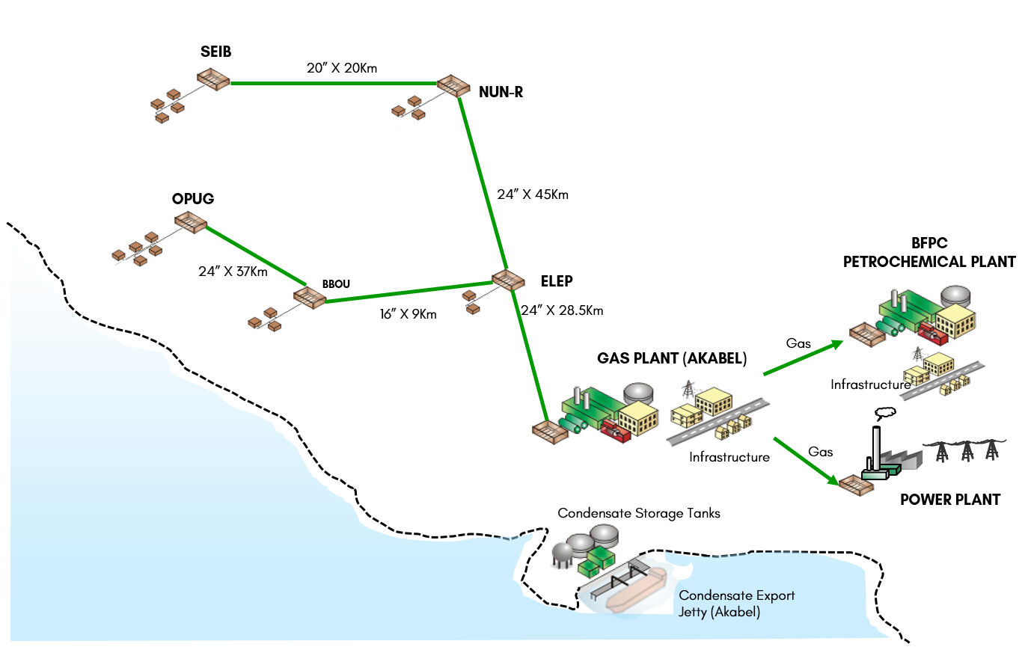
Figure 3.1: Regional Location Plan and the Gas Gathering & Evacuation Concept - Schematics
The Gas Plant will comprise three trains, (each with a processing capacity of 150 MMscfd, - corresponding to 300 MMscfd capacity at 3 x 50%); and condensate storage system capacity of 50,000 Tonnes.
It will be located in Akabel, Brass Island, in Brass LGA of Bayelsa State of Nigeria, near the shores of Atlantic Ocean, - in the same complex as the Petrochemical Plant & Power Plant it will be supplying the processed gas.
  - The Gas Plant Site
The aerial photograph showing the plant site is shown below, holding all the three plants, - the Gas Plant, the Petrochemical Plant, and the Power Plant.
Figure 3.2: Aerial Photograph of Plants Site

  - The Gas Gathering & Evacuation Concept
The gas gathering concept & the gas transportation to the Gas Plant will be as follows:
- Gathering of each field well production through its wellhead flowline to the Field’s Central Manifold Header (FC-MH) / Field’s Central Manifold (F-MF).
- Transportation of the F-MF inventory through Bulkline to a remote Satellite Manifold (S-MF), or to the Evacuation Manifold (E-MF), as the case may be for fields (BBOU & ELEP) that are within the vicinity of the E-MF.
- Transportation of the S-MF inventory through Bulklines to the E-MF.
- Transportation of the E-MF inventory through a Trunkline to the Pipeline End Manifold (PLEM) at Akabel, and from there as feedstock inlet stream to the Gas Processing Plant.
The selected wellhead gas gathering and evacuation concept is shown below, with on-stream schedule for the various phases. The selection resulted from CAPEX comparison of six options that made the final shortlist in the concept select exercise.
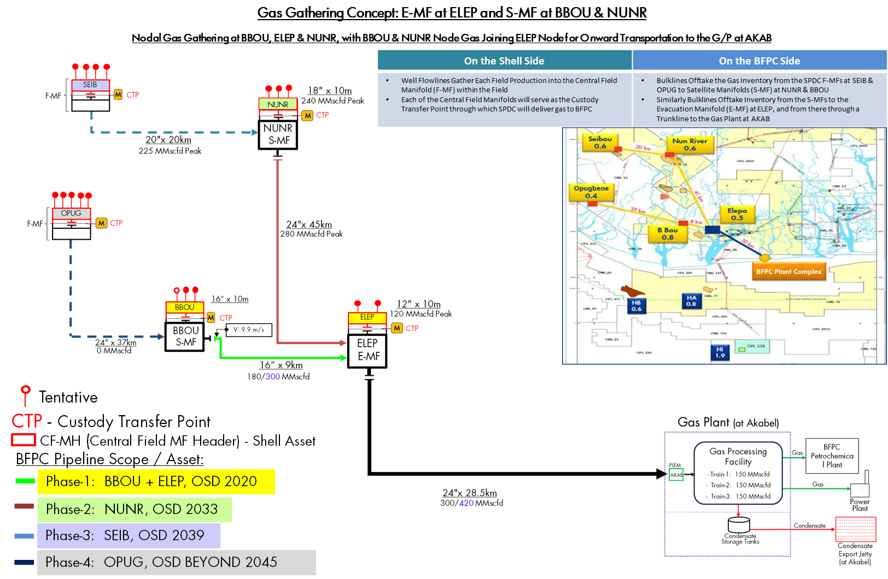
Figure 3.1: Wellhead Gas Gathering & Flow Schematics to Gas Processing Plant
The gas will be delivered raw to the gas processing plant for NGL extraction and conditioning of the lean gas to specifications of the petrochemical / power plants.
  - The Gas Gathering & Evacuation Options
The options considered and their installation cost estimates are shown as follows:
Option – 1: S-MF at BBOU & NUNR, and E-MF at ELEP - With OPUG Production Passing through BBOU to ELEP
Capex Estimate $469.9 mln - Eliminates need for BBOU – ELEP 9km section for the 24” OPUG B/L.
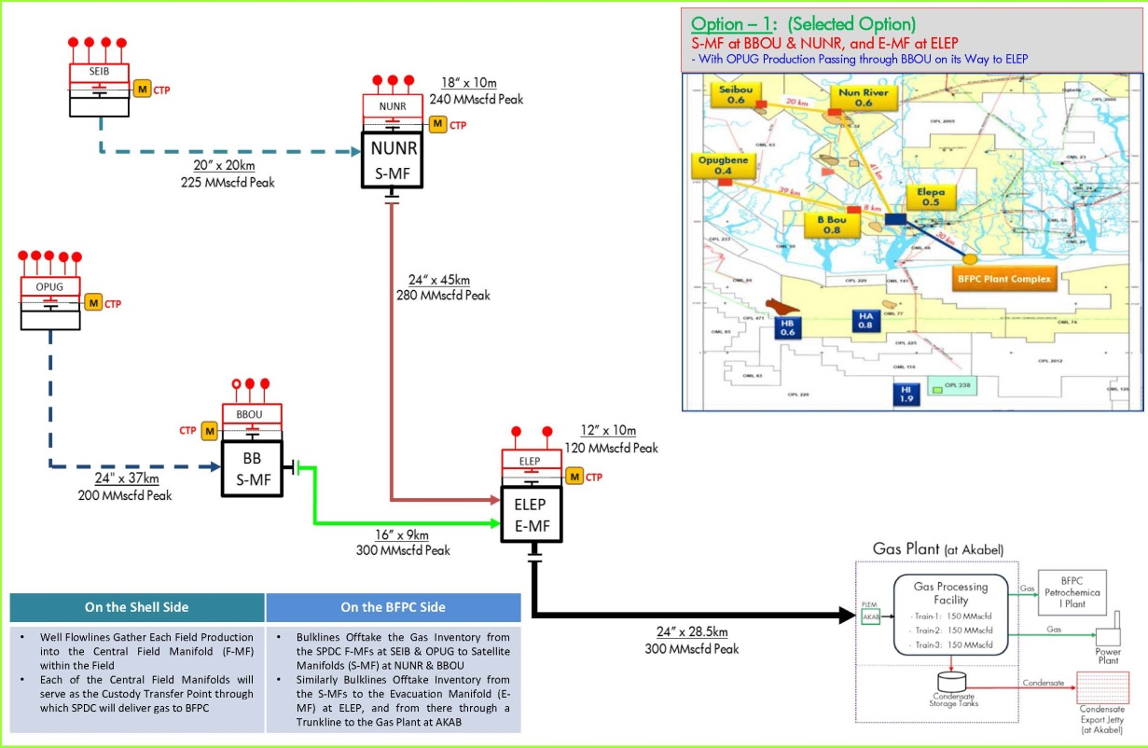
Option – 2: S-MF at NUNR & E-MF at ELEP - With OPUG Production Direct to ELEP
Capex Estimate $501 mln
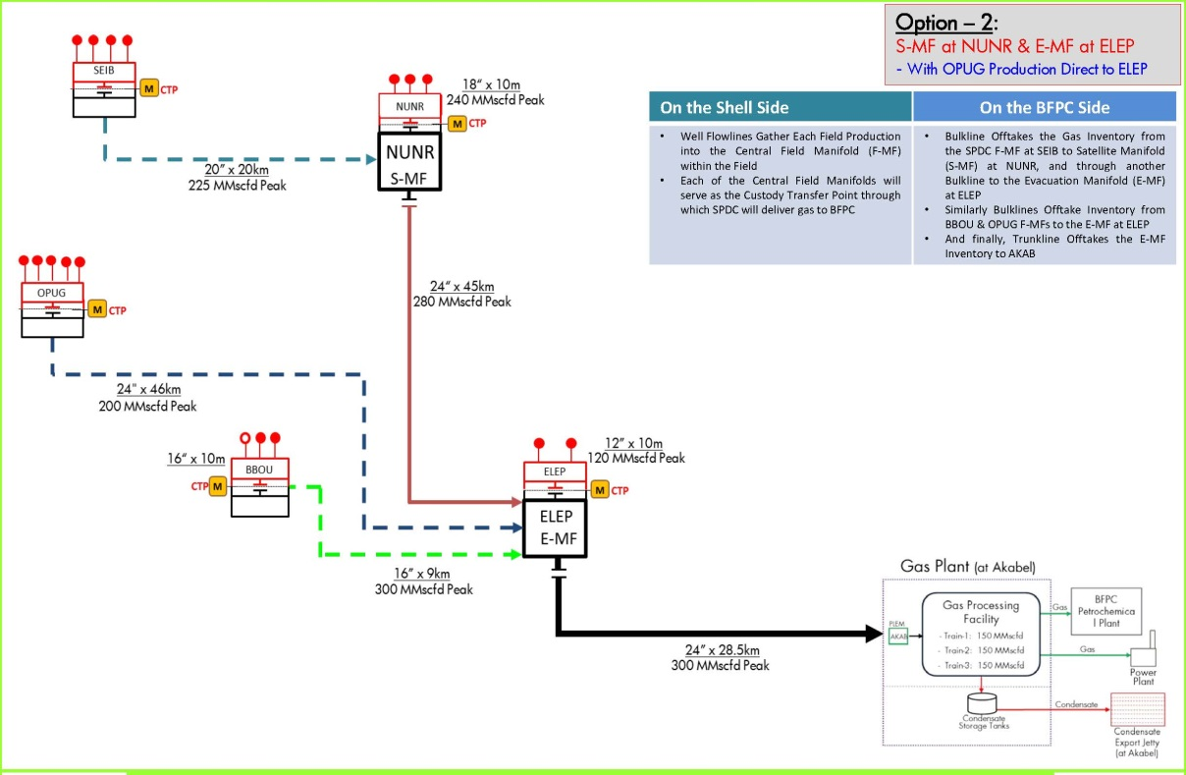
Figure 3.2: Wellhead Gas Gathering & Flow Schematics – Options 1 & 2

Option – 3: S-MF at NUNR, and E-MF at BBOU
Capex Estimate $497.9 mln
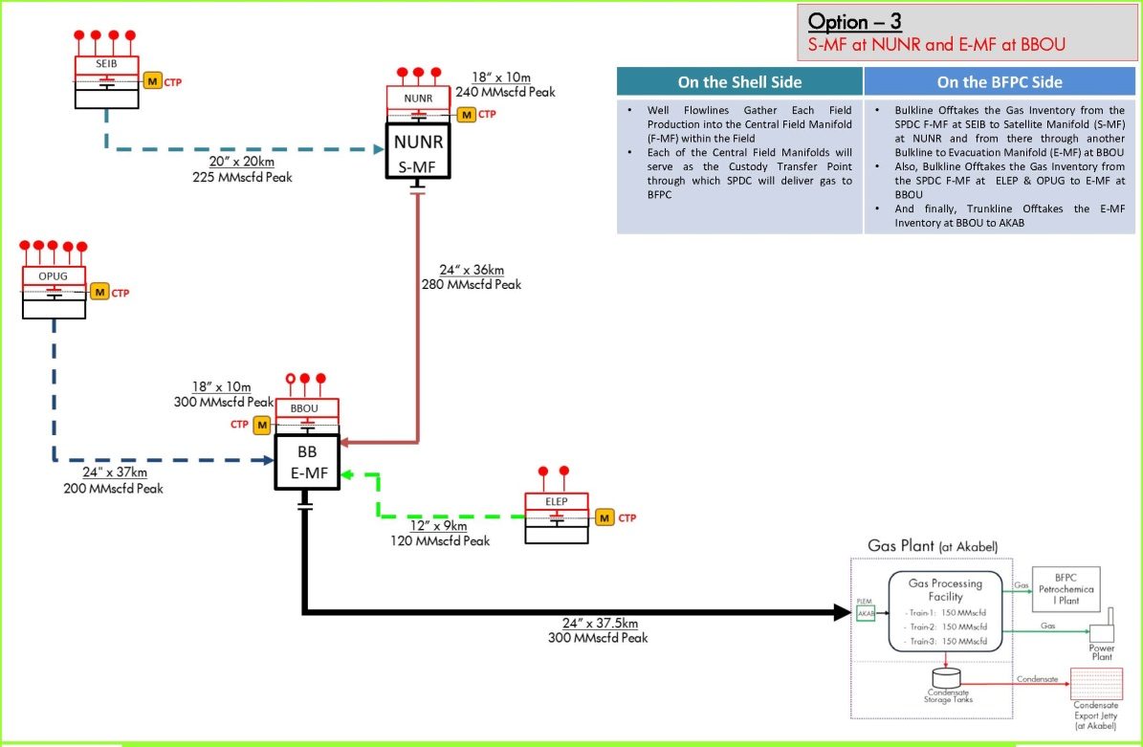
Option – 4: S-MF at DBUC & E-MF at ELEP
Capex Estimate $449.8 mln – Cost attractive but with S-MF at an external location at DBUC, - a situation not acceptable to BFPC owing to the additional ER risk it will pose
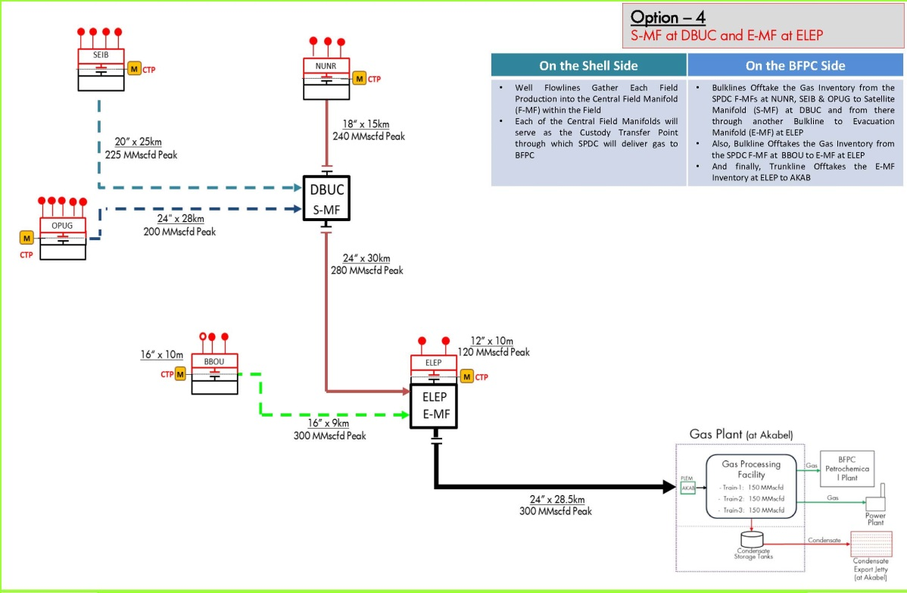
Figure 3.3: Wellhead Gas Gathering & Flow Schematics – Options 3 & 4

Option – 5: S-MF at DBUC, and E-MF at BBOU
Capex Estimate $446.3 mln – Cost Attractive / Lowest but with S-MF at an external location at DBUC, - a situation not acceptable to BFPC owing to the additional ER risk it will pose
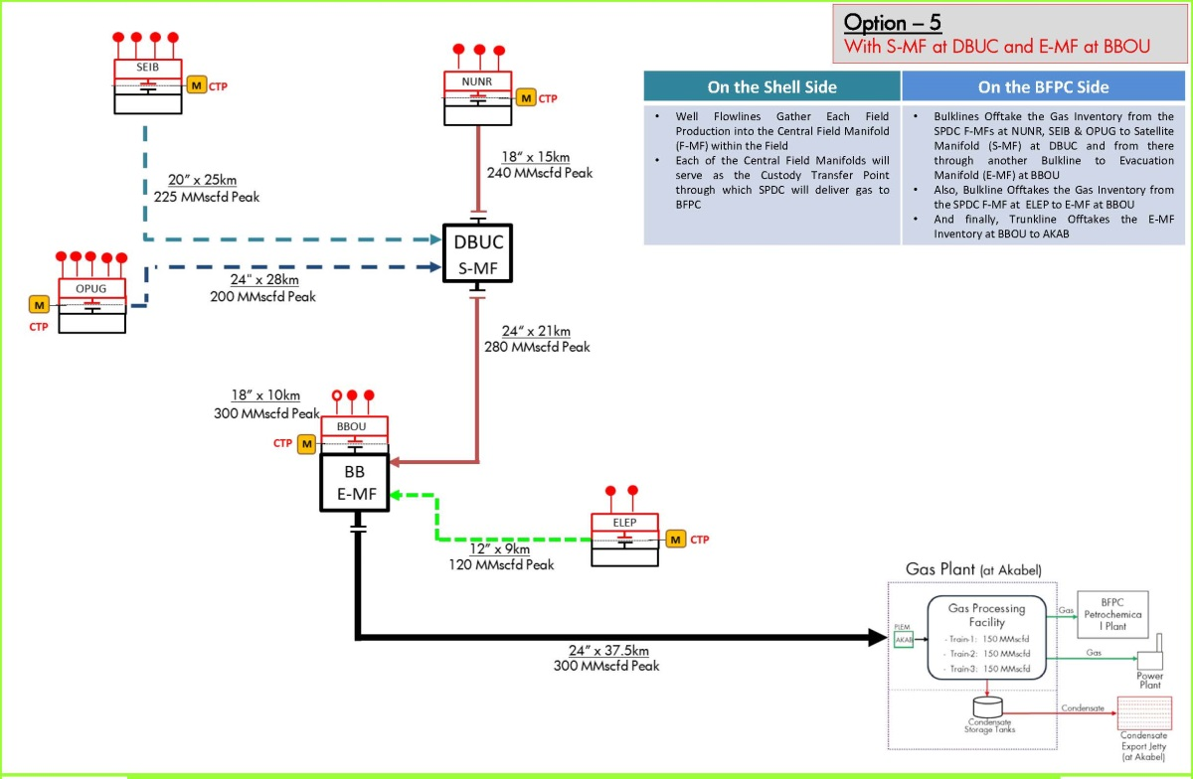
Option – 6: Bulkline From Each Field Direct to AKAB
Capex Estimate $926.3 mln - Demonstrates the high cost of individual manifold transport, compared with satellite concept
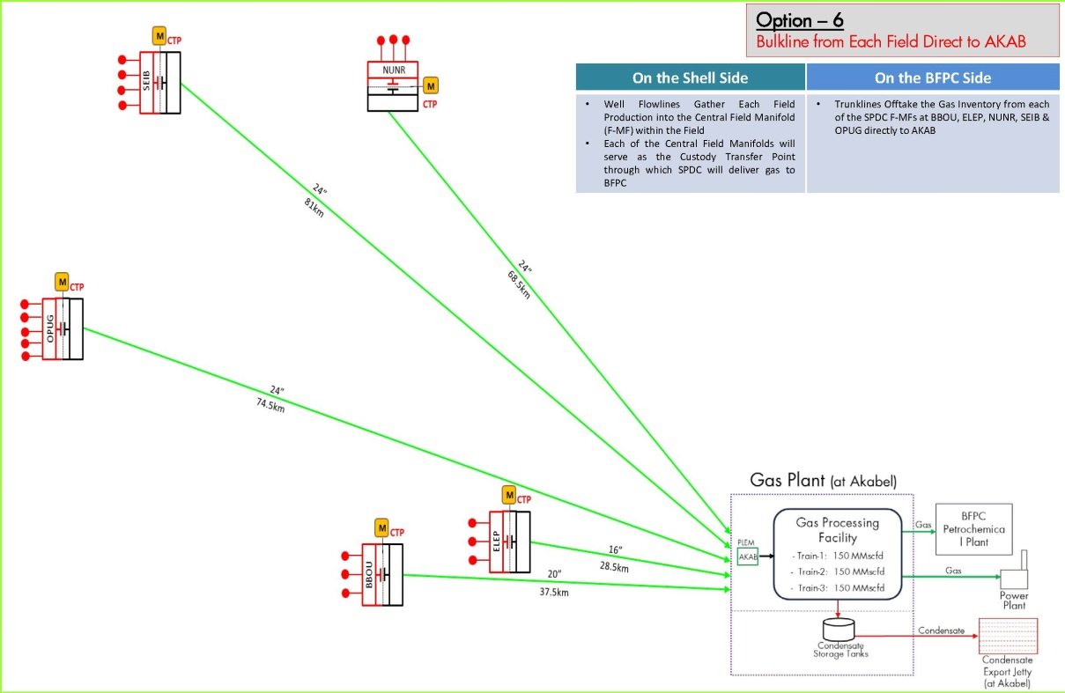
Figure 3.4: Wellhead Gas Gathering & Flow Schematics – Options 5 & 6
  - The Manifolds Concept
Three categories of manifolds were conceptualised, - Field Manifold (F-MF), Satellite Manifold (S-MF), and Evacuation Manifold (E-MF).
- Field Central Manifold (F-MF) that receives the field’s production gathered through its wellheads flowlines to the Field’s Central Manifold Header (FC-MH.
- Satellite Manifolds (S-MF) which receives inventory from the Fields’ Manifolds (F-MF) through their bulklines. There are two satellite manifolds, - at BBOU and NUNR.
- Evacuation Manifold (E-MF) which receives inventory from the Satellite Manifolds (S-MF) through their bulklines. The evacuation manifold serves as the last gathering point of all fields production, and delivers same to the gas processing plant.
Field Manifold (F-MF)  At SIEB & OPUG | Satellite Manifold (S-MF)  At BBOU & NUNR | Evacuation Manifold (E-MF)  At ELEP
At SIEB & OPUG | At BBOU & NUNR | At ELEP
Figure 3.5: Manifold Concept & Categories
A desirable situation will be to power the manifolds to enable automation, - motorisation of valves, etc, and in that case underground armoured cables will be installed to transport electricity from the IPP at Akabel to the various remote manifolds. However, in as much as that will be ideal, the concept will be reviewed during FEED in the light of cost savings, and risk assessment with particular reference to widespread vandalisation of such facilities in the region, - to re-confirm that the concept will be worth doing. Otherwise, the platform will be designed without the concept of automation, with provision only for solar power to provide basic warning lighting at night.

  - The Gas Processing
The proposed gas plant will be full spectrum gas processing plant with capability for NGL extraction, condensate stabilisation & storage, and conditioning of the lean gas to specifications of the petrochemical & power plants, in the following main steps:
- Gas Separation
- Gas Drying
- NGL Recovery
- Fractionation
- Condensate Stabilisation
The plant will be located in Akabel, in the same complex as the Petrochemical Plant & Power Plant it will be supplying the processed gas, but 28.5 km downstream of the evacuation manifold at Elepa from where it will be receiving its feedstock of wet gas.
It will comprise three trains, (each with a processing capacity of 150 MMscfd) and condensate storage capacity of 50,000 Tonnes. Two trains will be installed initially, in strategic fit with the current GSPA for 270 MMscfd ACQ, while the 3rd train will be installed later, as will be dictated by additional GSPA.
Processing of gas will start with phase-1 production, - initially from BBOU, then joined by ELEP a couple of years later, and in both cases with peak receipt of 300 MMscfd.
The process flow scheme of the process systems of the gas plant is shown in Fig 3.6 below, including the expected products yields for 300 MMscfd wet gas feed from the BBOU / ELEP phase-1 production, with indications for 150 MMscfd and 450 MMscfd.
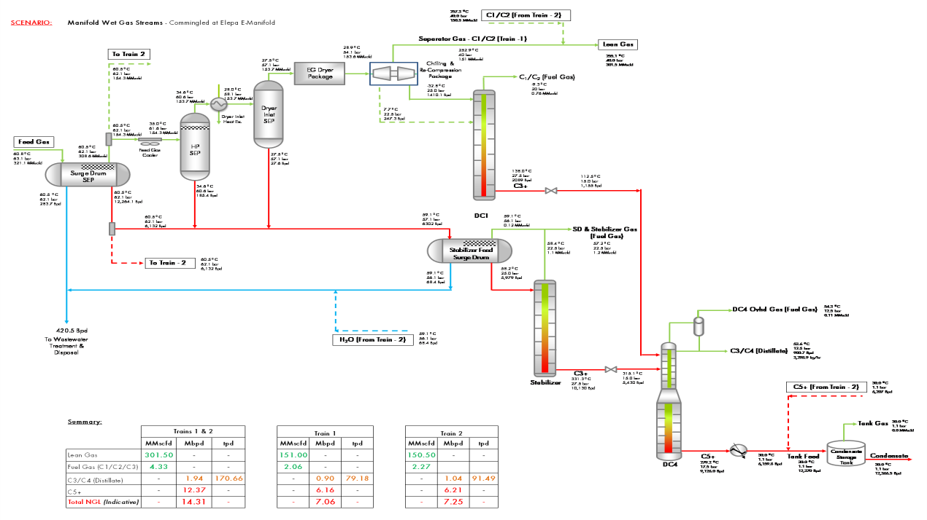
Figure 3.6: Process Flow Scheme – AKAB Gas Processing Plant
options considered and their installation cost estimates are shown in table 3.1:
Table 3.1: Wellhead Gas Gathering & Flow Schematics – Options 1,& 2.
 | Option Description | Pipelines  CAPEX $mln | Schematics | Remarks
1 | S-MF at NUNR, and E-MF at ELEP  With OPUG Production Passing through BBOU  on its Way to ELEP | 469.9 | 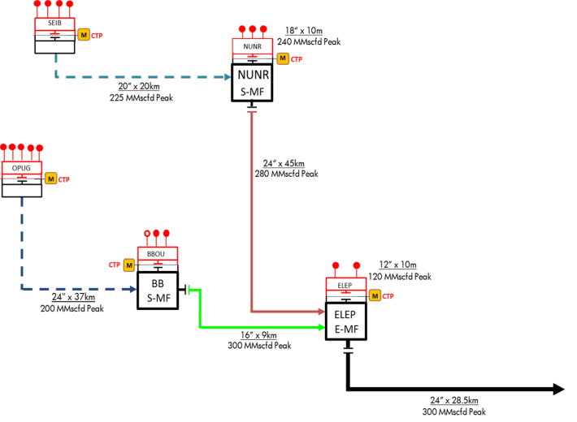 | Eliminates need/cost for BBOU – ELEP 9km section for the 24” OPUG B/L.  Though constrained to reduced 16" conduit to ELEP, but that is manageable
2 | S-MF at NUNR, and E-MF at ELEP  With OPUG Production Direct to ELEP | 501 | 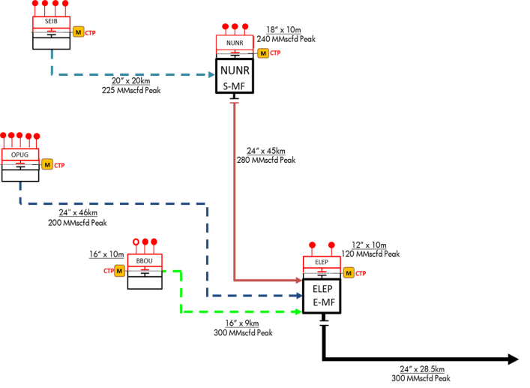
3 | S-MF at NUNR, and E-MF at BBOU | 497.9 | 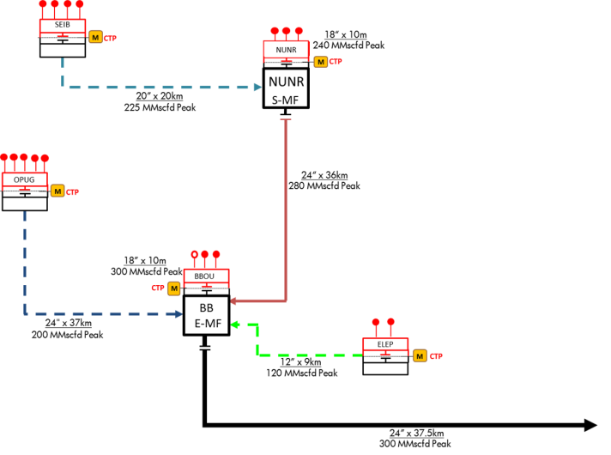

Table 3.1 (contd.): Wellhead Gas Gathering & Flow Schematics – Options 3, 4, & 5.
 | Option Description | Pipelines  CAPEX $mln | Schematics | Remarks
4 | S-MF at DBUC, and E-MF at ELEP | 449.8 | 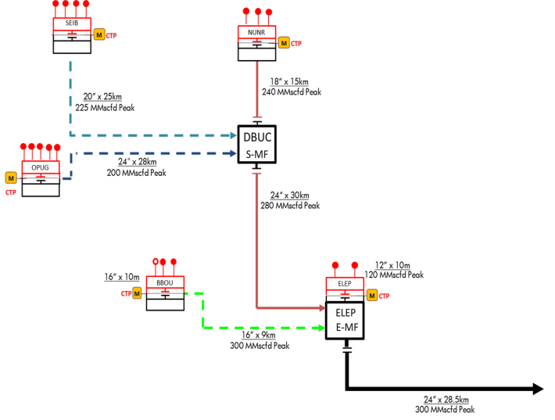 | Cost attractive but with S-MF at an external location at DBUC, - a situation not acceptable to BFPC owing to the additional ER risk it will pose
5 | S-MF at DBUC, and E-MF at BBOU | 446.3 | 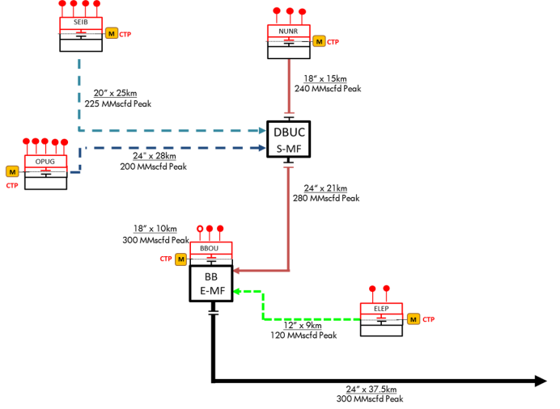
6 | Bulkline from Each Field Direct to AKAB | 926.3 | 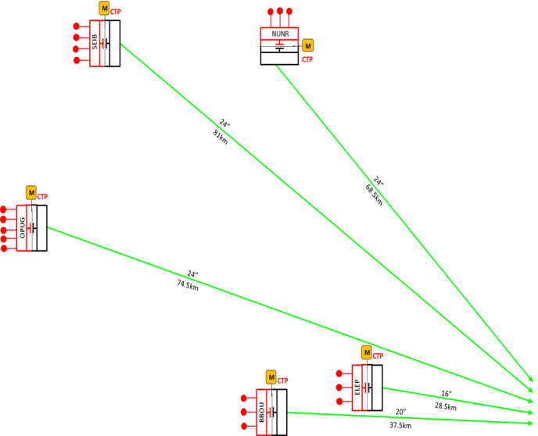 | Demonstrates the high cost of individual manifold transport, compared with satellite concept

- Feedstock Supply & Product Evacuation Scheme
Ref: EA SPDC-BFPC UGS-GEP CSM RPT-001-A01_Concept Select Study – Project Concept & Proposed Site for the Project
The feedstock supply and product evacuation involves the gathering of the fields’ raw wellhead gas, and transporting same through a network of bulklines and trunkline to the Gas Processing Plant for processing into lean gas and condensate.
The lean gas is supplied as feedstock to the Petrochemical Plant for methanol & urea production, and also to the Power Plant for power generation.
The condensate is exported via a delivery to the condensate export jetty from where offtakers take delivery. The condensate export jetty is within the BFPC plants’ captive export jetty, from where all plants’ products (condensate, methanol, and urea) are exported.
  - The Feedstock & Products Evacuation Schematics
The feedstock and product evacuation schematics is shown below, - involving gathering and transporting the fields’ raw wellhead gas via a network of flowlines & pipelines to the Gas Processing Plant, and the delivery of the Gas Plant lean gas (product) to the the Petrochemical & Power Plants, and the condensate (product) to the condensate export jetty for export to buyers.

Figure 4.1: Feedstock & Products Evacuation Schematics

APPENDIX
- Wellhead Gas Gathering Schematics & Flow Parameters to Gas Processing Plant
- Options for WHGG & Flow Schematics
- PFS AKAB Gas Plant
- Fishbone

Appendix-1: Well Gas Gathering Schematics
Appendix 1 | EA/SPDC-BFPCUGS-GEP/BDM-PFS-001-A01  Wellhead Gas Gathering Schematics & Flow Parameters to Gas Processing Plant

Appendix-2: Options for WHGG & Flow Schematics
Appendix 2 | EA/SPDC-BFPCUGS-GEP/CSM-PFS-001-A01  Options for WHGG & Flow Schematics

Appendix-3: PFS AKAB Gas Plant
Appendix 3 | EA/SPDC-BFPC UGS-GEP/BDM-PFS-002-A01  PFS AKAB Gas Plant

Appendix-4: Fishbone
Appendix 3 | EA/SPDC-BFPC UGS-GEP/CSM-SCH-001-A01  Fishbone

